Aireena Antony
DAF69 Batch

MINI PROJECT
DATA ANALYSIS USING EXCEL AND POWERBI

The Original dataset from which these analysis have made is given below for reference :-

https://www.kaggle.com/datasets/chandrachudsahi/e-commerce-sales-data

📌 Introduction

E-commerce platforms generate large volumes of transactional data that capture details such as product sales, customer demographics, and payment methods. However, raw data often contains duplicates, missing values, and inconsistencies that must be cleaned and transformed. By preparing the dataset in Excel and visualizing it in Power BI, businesses can convert this raw information into structured insights that highlight not only sales performance but also customer preferences in how they pay.

🎯 Business Goal

The main goal is to leverage cleaned and transformed data to improve sales strategy, customer experience, and operational efficiency. Key objectives include:
- Identify top-selling products and categories to optimize stock and promotions.
- Track sales trends over time for accurate forecasting.
- Analyze customer purchasing behavior to tailor marketing campaigns.
- Evaluate payment method usage (e.g., Credit Card, PayPal, COD) to understand customer preferences and reduce transaction friction.
- Detect underperforming products, regions, or payment channels to refine business focus.
- Build interactive dashboards in Power BI for real-time monitoring and decision making.

📊 Scope of Analysis

After cleaning and transforming the e-commerce dataset in Excel and visualizing it in Power BI, the scope of analysis will cover:

- Sales Performance:
  - Total revenue, average order value, and sales trends over time.
  - Identification of top-selling products, categories, and regions.

- Customer Insights:
  - Purchase frequency and customer segmentation.
  - Repeat vs. new customer contributions to revenue.

- Payment Method Analysis:
  - Distribution of transactions across payment methods (Credit Card, Debit Card, PayPal, Cash on Delivery, etc.).
  - Correlation between payment methods and order value or customer type.
  - Detecting preferred payment channels to improve checkout experience.

- Operational Efficiency:
  - Order fulfillment rates and delivery timelines.
  - Highlighting underperforming areas or bottlenecks.

- Interactive Dashboards:
  - Dynamic filters for product, region, and payment method.
  - Real-time KPIs for management decision making.

Excel Cleaning & Transformation
Conversion of Data set - The raw dataset was converted into tables with filer options and arranged from smallest to biggest format And corrected the inconsistent values.
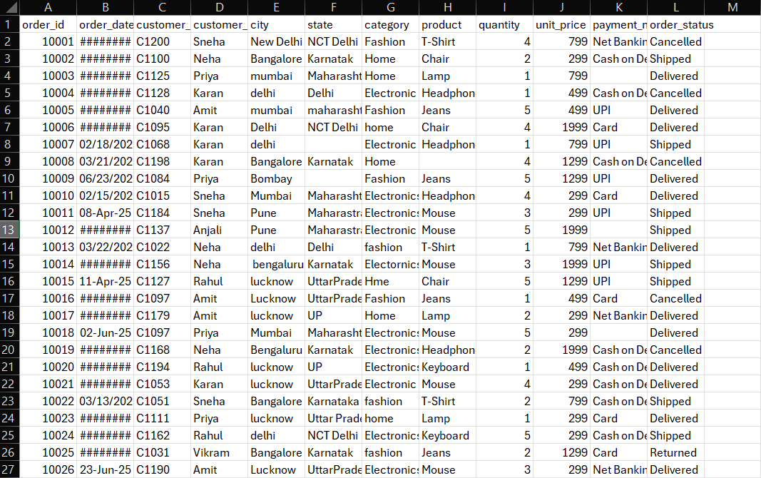
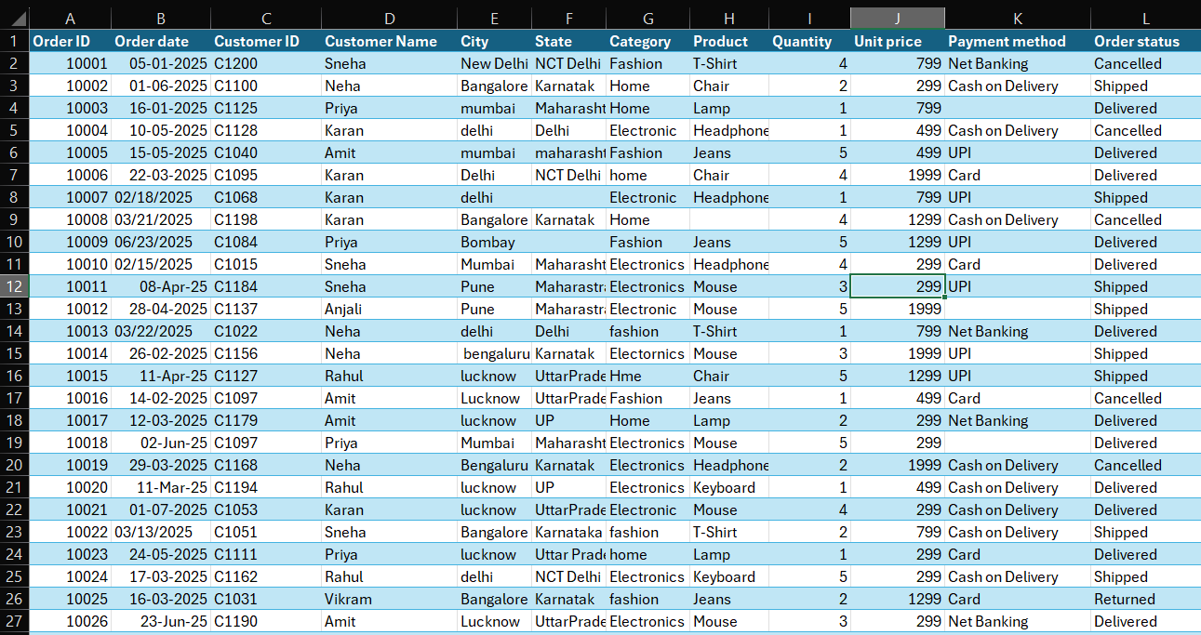
Removing Duplicate values – Duplicate values present in the data set were removed using excel.
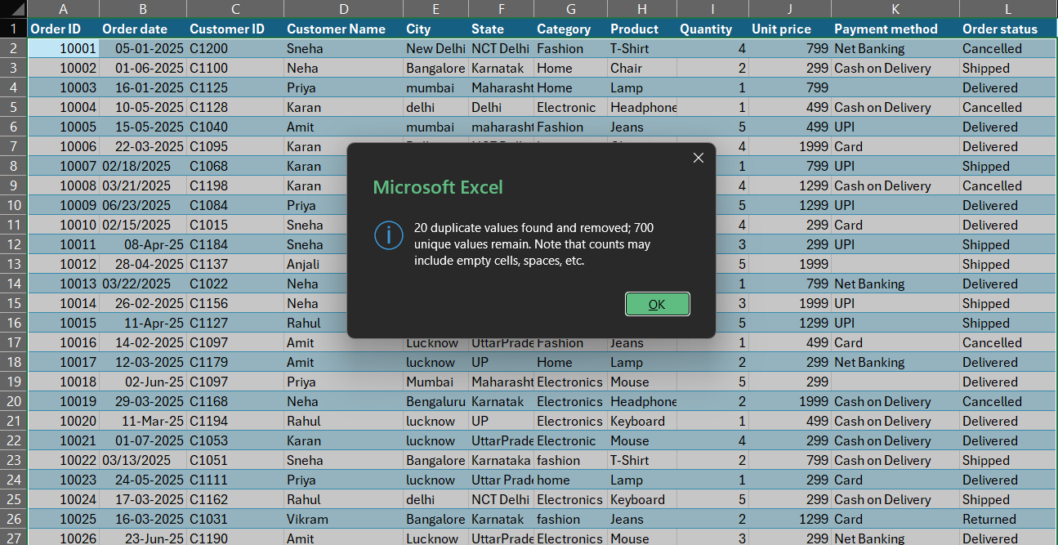

Identifying Missing values – Missing values was identified and imputed unknown values in the missing columns.
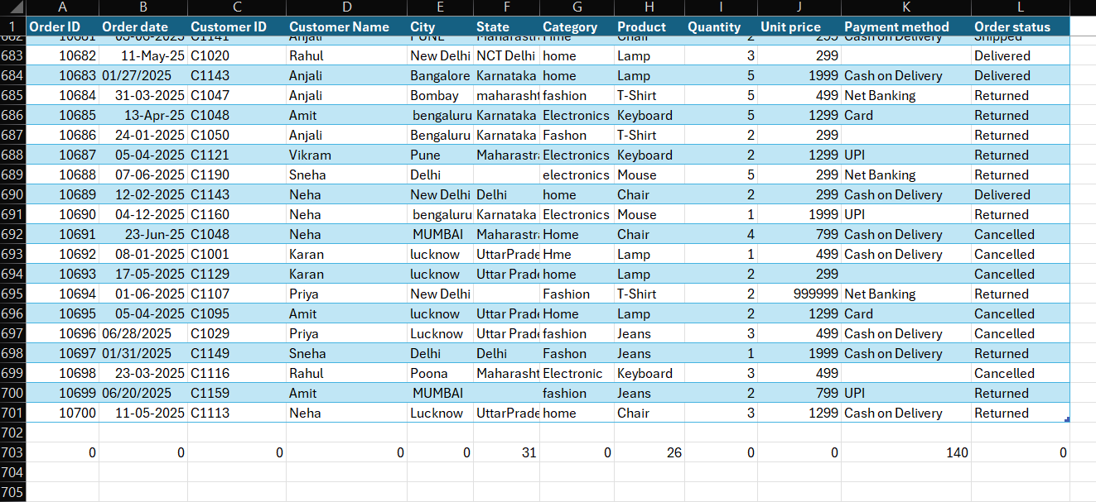
Created a table using LOOKUP function.
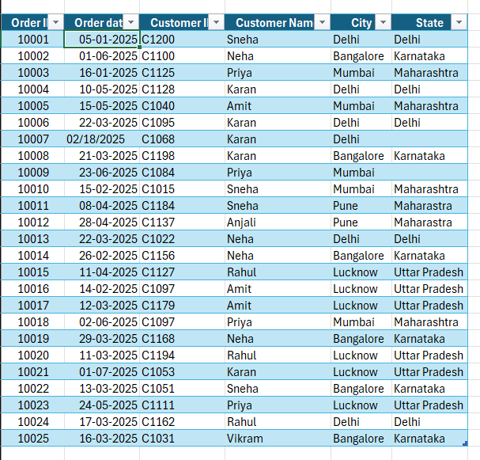
Correct various mistakes using find and replace method from the data set for clean and better analysis.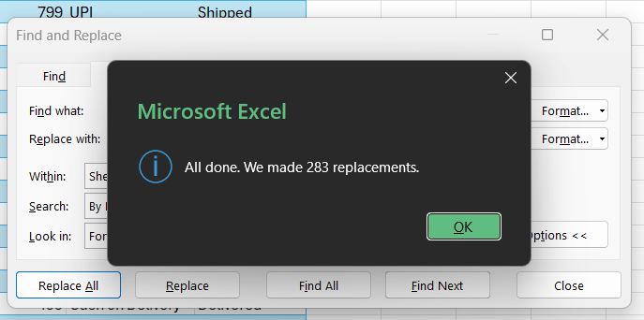
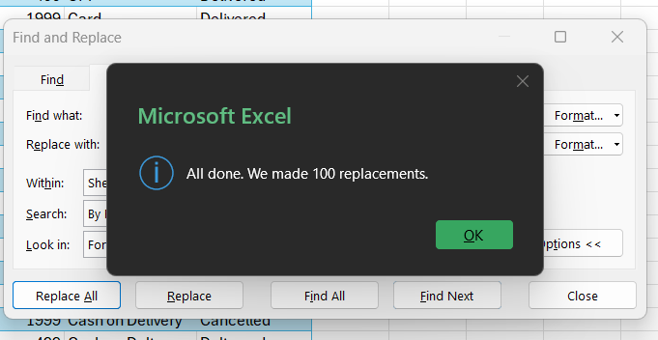
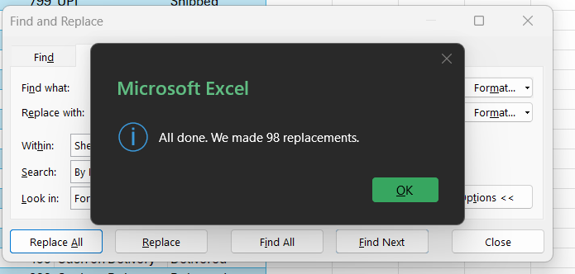
Unit price column data type has been changed to Currency format, imputed ‘Unknown’ in the missing value fields by adding two columns named ‘State replaced’ & ‘Product replaced’
Also added a new column named ‘Price Range’ using IF(ISBLANK) function to identify the prices with ‘High Price’’ and ‘Standard Price’.
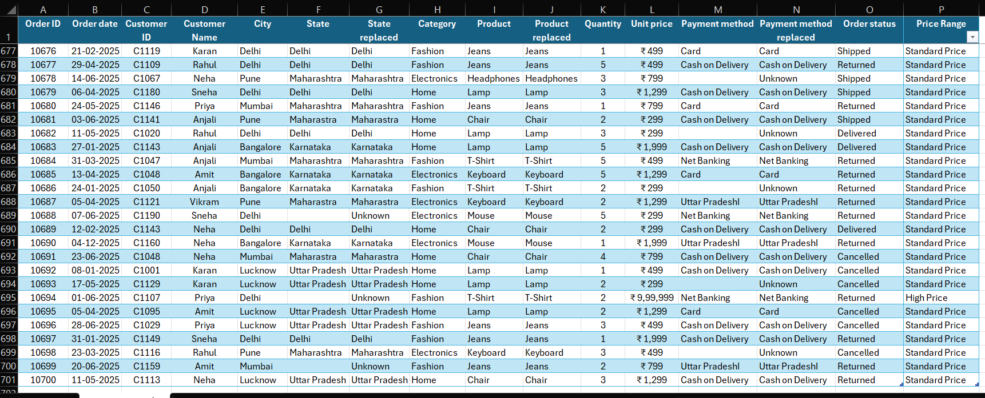
Functions such as SUM, MAXIMUM, MINIMUM, COUNT, AVERAGE, STANDARD DEVIATION were used in the dataset.
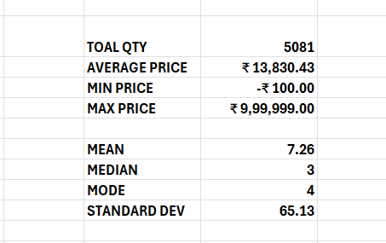
Applied Conditional formatting in Unit price column using Color scales and highlighted the cells named ‘High Price’ using conditional formatting.
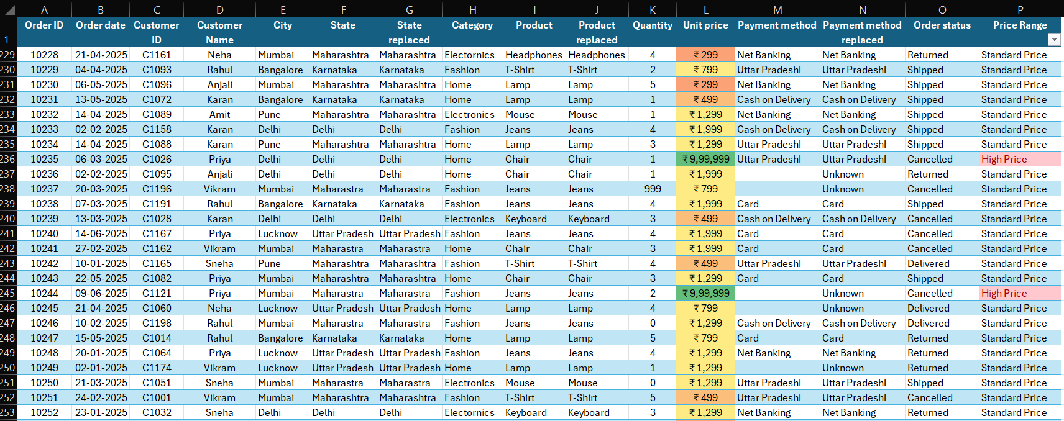
Pivot Tables
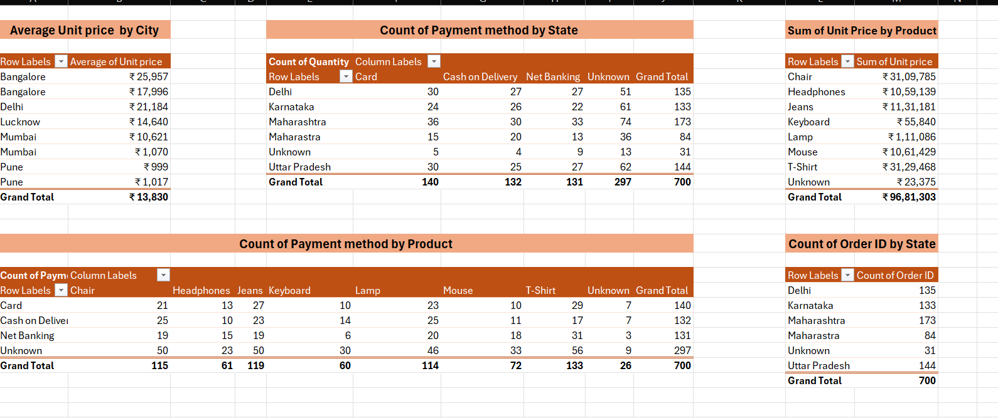
Pivot Charts
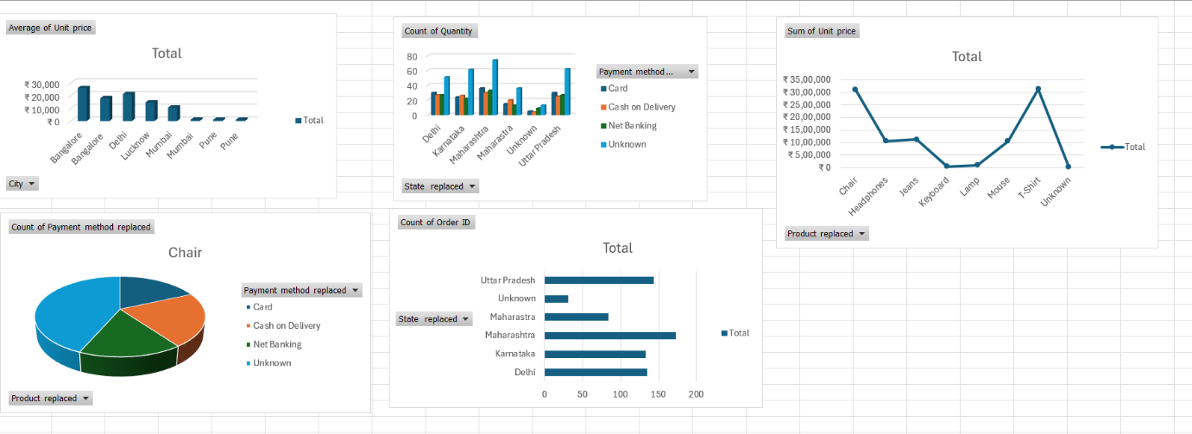

Sales Dashboard
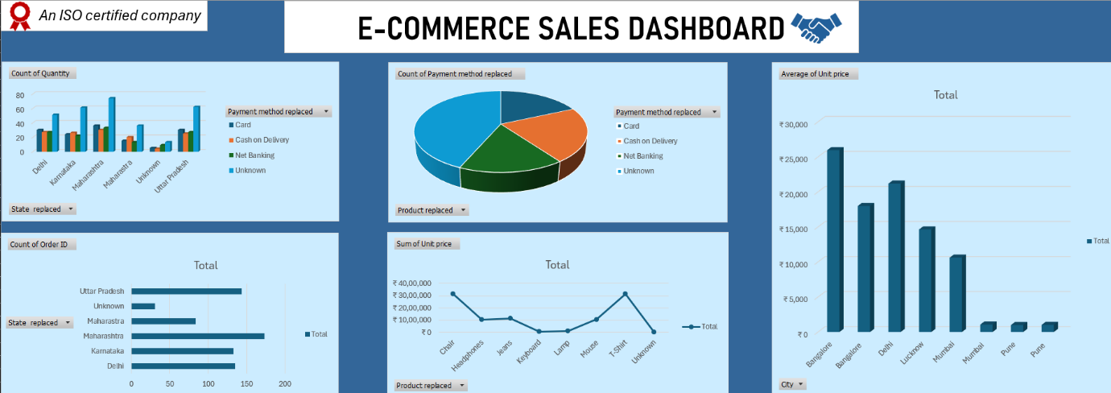
Used 05 types like Clustered column chart, 3-D Pie Chart, Line chart and Horizontal Bar Chart.

Data Visualisation in PowerBI
Changed the data types in Power Query editor and loaded the data.
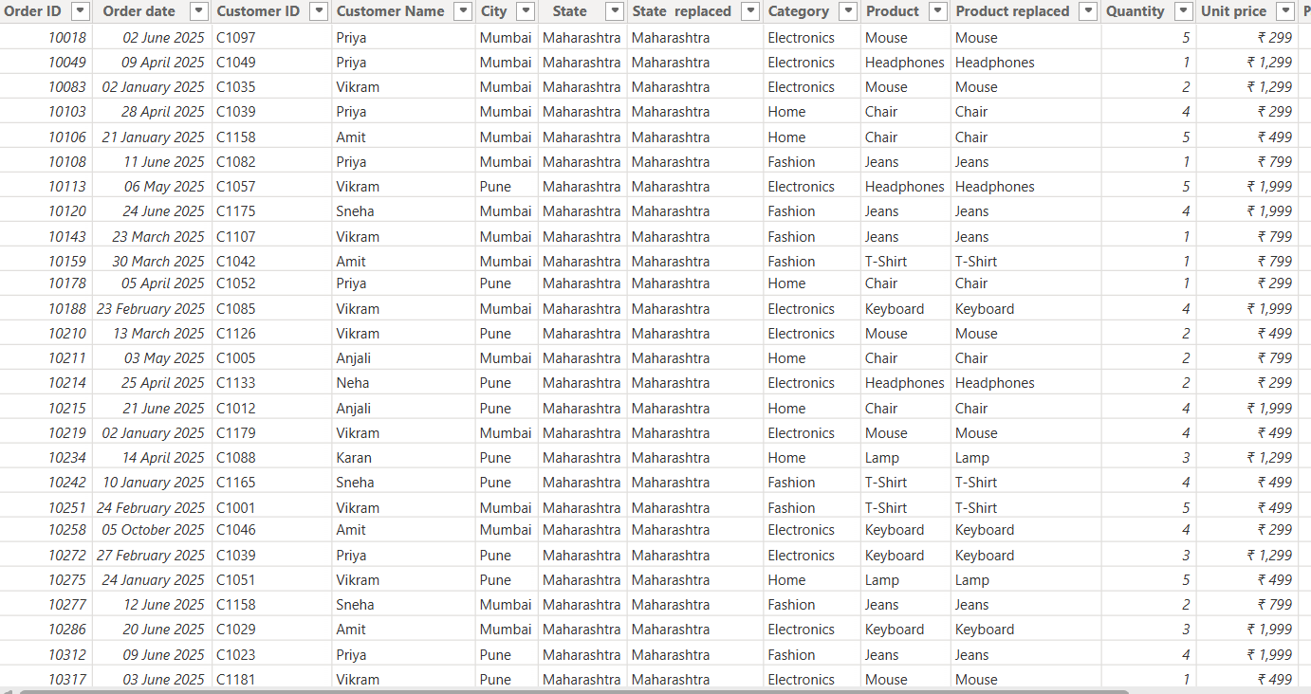

Added new calculated column to find the Total Sales for easy interpretation.
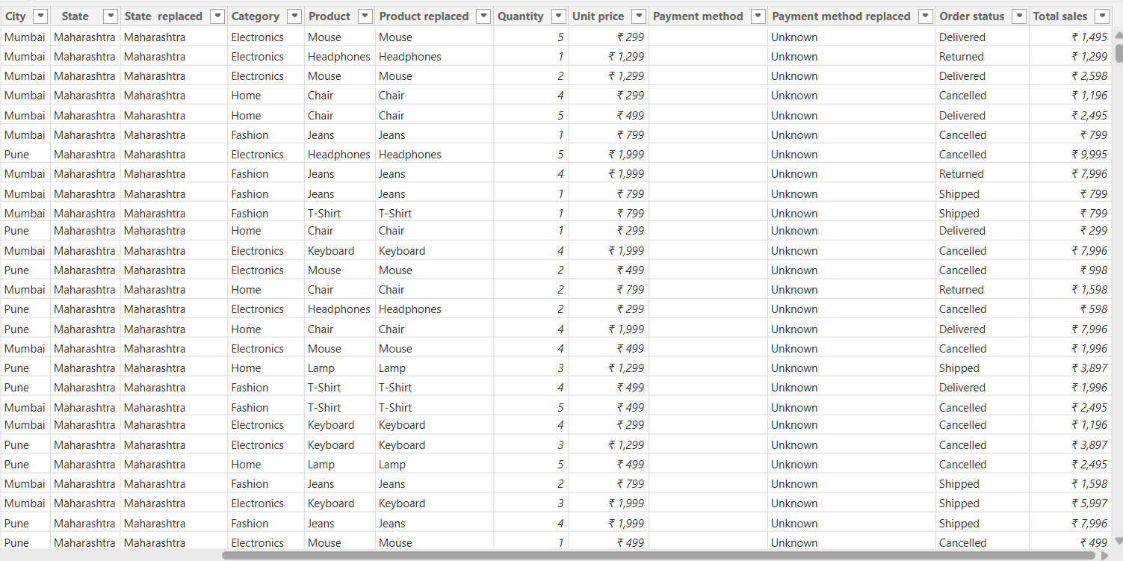

Created an interactive E-Commerce Sales dashboard using 08 types of charts and graphs including :-
- Clustered column chart (02)
- Pie chart
- Matrix
- Card
- Donut chart
- Funnel chart
- KPI
For better interpretations and analysis, slicers and drill-downs are also included in the dashboard.
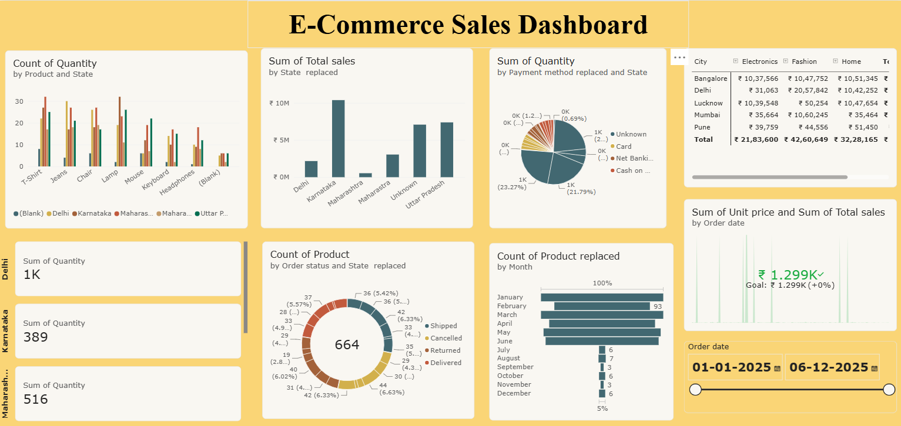
Conclusion
The e-commerce sales analysis reveals clear insights into product performance, regional sales distribution, and customer payment preferences. Delhi and Maharashtra emerge as leading states in total sales, while T-shirts, chairs, and jeans are among the most frequently purchased items. The Card and Net Banking payment methods dominate transactions, indicating strong digital adoption among customers.
Monthly trends show higher product replacements in February and March, suggesting seasonal demand or return cycles. The overall sales goal of ₹1.299K has been achieved, reflecting consistent performance across categories such as Electronics, Fashion, and Home.
By integrating these insights, the business can focus on enhancing inventory planning, optimizing payment experiences, and refining marketing strategies to sustain growth and improve customer satisfaction.

